Project Database Design

## Left Join:

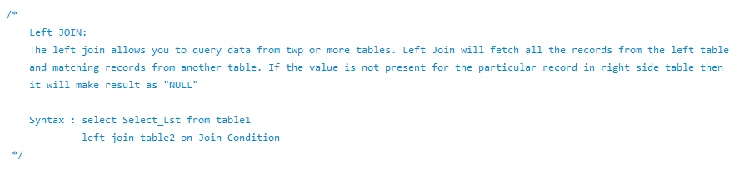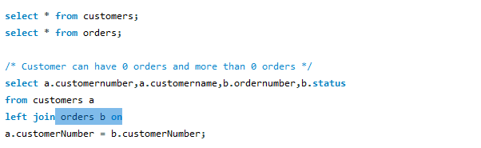

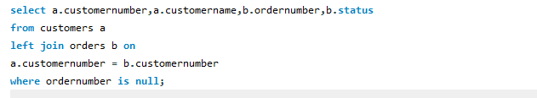

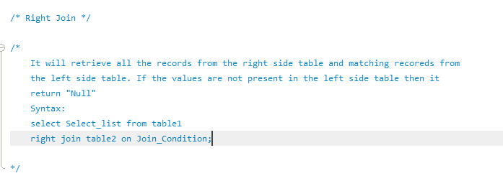



Advanced : Stored Procedures

Introduction to Database Objects:

1. tables : Data storage

2. stored procedures

3. views

4. triggers

5. indexes

6. Full-Text search

7. Functions

Use of other objects makes the data secure, it means all these objects will provide the security for the data in the tables.

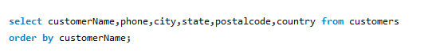

If you want to save this query on the database server for future reference we do use stored procedures.

To create the procedure we can use “Create Procedure “.

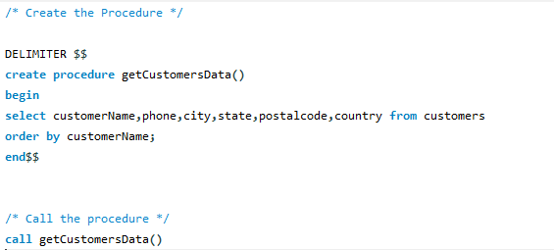

Procedure : Basically pre-compiled block of code and anytime when we call it just execute the query.

Query or Statement : Statement or Query everytime compile and everytime that will be executed.